GPS
Personal

Tracker

User Manual

V1.0

HS-500P

Contents

1.Product Overview .................................................................................................................. -2-
2.For Your Safety ..................................................................................................................... -3-
3.HS-500P Characteristics ............................................................................................................. - 3-
4.Getting Started..................................................................................................................... -4-
4.1 Hardware and Accessories ............................................................................................. - 4-
4.2 View ........................................................................................................................... - 5-
4.3 Functional Parts............................................................................................................ - 5-
4.4 First Use ...................................................................................................................... -6-
5. Change Password ................................................................................................................. -7-
6. Time Zone........................................................................................................................... - 7-
7. Track ..................................................................................................................................-7-
7.1 Track by SMS ............................................................................................................... - 7-
7.2 Track by Calling ............................................................................................................ - 8-
7.3 Track by Preset Interval ................................................................................................. - 8-
7.4 Google Earth and Google Map ........................................................................................ - 8-
7.5 Track by GPRS between Server and Tracker .....................................................................- 9-
7.5.1 Set Tracker‟s GPRS ID ........................................................................................... - 9-
7.5.2 Set APN .............................................................................................................- 10-

7.5.3 Set IP and Port ...................................................................................................- 10-
7.5.4 Set DNS Server IP (optional) ................................................................................- 10-
7.5.5 Enable GPRS Tracking ..........................................................................................- 10-
7.5.6 Set GPRS Time tracking .........................................................................................- 10-
7.5.7 Set GPRS Interval ...............................................................................................- 10-
8. Authorization......................................................................................................................- 11-
9. Call Function ......................................................................................................................- 11-
9.1 Receiving Phone Call ....................................................................................................- 11-
9.2 Making Phone Call .......................................................................................................- 12-
10. Speeding Alarm.................................................................................................................- 11-
11. Movement/Geo-fence.........................................................................................................- 11-
11.1 Movement Alarm........................................................................................................- 12-
11.2 Geo-fence Alarm........................................................................................................- 12-
12. Set Sensitivity of Tremble Sensor ........................................................................................- 13-
13. Listen-in (Voice Monitoring) ................................................................................................- 13-
14. GPS module sleep mode ..............................................................................................- 14-
15. Power Down .....................................................................................................................-14-
16. Get IMEI ..........................................................................................................................-14-
17. Initialization .....................................................................................................................-14-
18. Password Initialization .......................................................................................................- 15-
19. Parameter Editor ...............................................................................................................-15-
Annex 1. SMS Command List ...................................................................................................- 15-
Annex 2. Troubleshooting ........................................................................................................-20-
Copyright and Disclaimer ........................................................................................................-21-
Contact us .........................................................................................................................- 21-

1.Product Overview

The HS-500P is a GPS/GPRS based personal tracking device, which is compact and easy to use.

HS-500P has inbuilt GPS module to obtain accurate position data and utilizes its GSM capability to send the
position data to a specified mobile phone or server base to allow users to monitor people or pets using the
tracker.

HS-500P has the following functions and features:

●
●
●
●
●
●
●
●
●
●
●
●
●
●
●
●

SMS and GPRS TCP/UDP Communication
AGPS ( with GSM Base Station ID)
Track on demand
Show location directly on mobile phone
Track by time interval
Track by Distance
Listen-in (voice monitoring)
Inbuilt motion sensor for power saving
SOS panic button
Movement alarm
Geo-fencing control
Low battery alarm
Speeding alarm
GPS blind area alarm
ARM processor supports one second a separate fast-track real-time monitoring data

2.For Your Safety

Read these simple guidelines. Not following them may be dangerous or illegal.

Switch on safely

Switch off in hospitals

Switch off in aircraft

Switch off when refueling

Switch off near blasting

Qualified service

Water resistance

Do not switch on HS-500P when wireless phone use is prohibited or when it may
cause interference or danger.
Follow any restrictions. Switch HS-500P off near medical equipment.
Follow any restrictions. Wireless devices can cause interference in aircraft.
Do not use HS-500P when at a refueling point. Do not use near fuels or
chemicals.
Follow any restrictions. Do not use HS-500P when blasting is in progress.
Only qualified personnel can repair HS-500P.
HS-500P is not fully water resistant. Keep it dry. Use waterproof bag if

necessary.

3.HS-500P Characteristics

Items | Specification
Charging Voltage | DC 4.2-5V/500-1000mA (Mini USB port)
Internal Battery | Non removable polymer battery is 2800 Mah (3.7V)
Dimension | 67 mm × 53 mm × 22 mm
Weight | 70g (with battery)
Operating temperature | -20°to 55°C
Humidity | 5% to 95% Non-condensing
GSM module | Quad Band GSM 850/900/1800/1900Mhz
GPS Chipset | latest GPS SIRF-Star III chipset
GPS Sensitivity | -158Db
GPS Frequency | L1, 1575.42 MHz
C/A Code | 1.023 MHz chip rate
Channels | 20 channel all-in-view tracking
Position Accuracy | 10 meters, 2D RMS
Velocity Accuracy | 0.1 m/s
Time Accuracy | 1 us synchronized to GPS time
Default datum | WGS-84
Reacquisition | 0.1 sec., average
Hot start | 1 sec., average
Warm start | 38 sec., average
Cold start | 42 sec., average
Altitude Limit | 18,000 meters (60,000 feet) max.
Velocity Limit | 515 meters/second (1000 knots) max.
Acceleration Limit | Less than 4g
Jerk Limit | 20 m/sec
Work time | 100 hours in power-saving mode and 50 hours in normal working mode
LED | 3 LEDs to show power, GPS, GSM and other status.
Button | 2 keys (S / B) is used to open and close the alarm LED and send location information

4.Getting Started

This section will describe how to set up your HS-500P.

4.2 View

Back View

4.3 Functional Parts
HS-500P you have two buttons and three with three different colors of the LED, to indicate the status of the unit.
SIM

LED

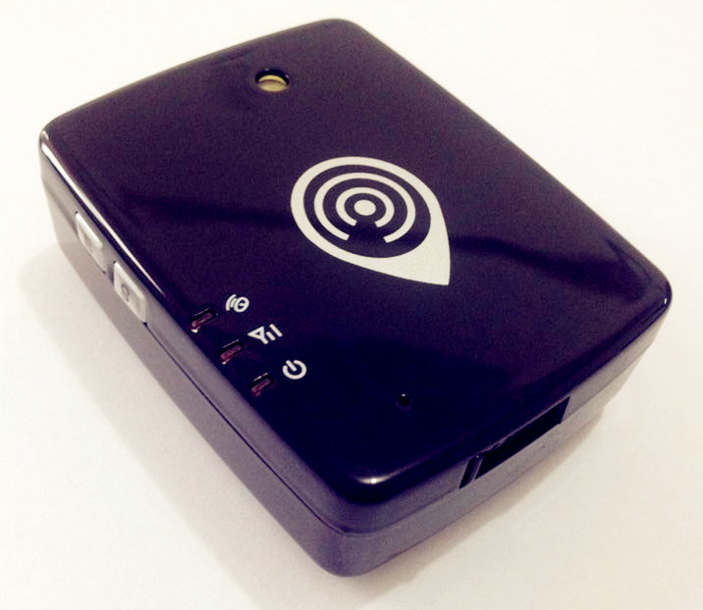
GPS signal
Mini USB port
Button S
GSM signal
Button B

microphone
Charge Indicator

Red LED - indicating battery status
Off | Power is off or charging is complete
Flashing (every 0.1 second) | Low battery
On | Charging
Flashing (1 second on and 2 seconds off) | Working
Blue LED - indicating GPS status
On | One button is being pressed
Flashing ( every 0.1 second) | The unit is being initialized
Flashing (0.1 second on and 2.9 seconds off) | HS-500P has a GPS fix
Flashing (1 second on and 2 seconds off) | HS-500P has no GPS fix
Green LED - indicating GSM status

On | One call is coming in / one call is being made
Flashing ( every 0.1 second) | The unit is being initialized
Flashing (0.1 second on and 2.9 seconds off) | HS-500P is connected to the GSM network
Flashing (1 second on and 2 seconds off) | HS-500P is not connected to the GSM network
Buttons
Power On/Off Button | Insert the SIM card machine automatically boot
S Button | S button for SOS distress alarm
B Button | B button is used to turn off the LED
Other Connectors
Mini USB | Used for charging, firmware update and configuration on PC. (USB Data  Cable or USB-to-Serial Adaptor is required for firmware update and  configuration)

4.4 First Use

Please read this manual before using your HS-500P.

4.4.1 Ensure that your HS-500P has a working SIM installed.
- Check that the SIM has not run out of credit (Test the SIM in a
phone to make sure it can send and receive SMS)
- Check that the SIM Lock code is turned off
- If you require the function of sending an SMS location report to
the authorized phone number when it makes a call to the HS-500P,
please make sure the SIM installed supports displaying caller ID.

4.4.2 Put the battery in HS-500P and charge the tracker for at least 5
hours in power-off status using the wall charger or car charger. Or
you can connect the tracker directly to computer by USB for
charging. Red light is on during charging and is off when charging is
complete.

4.4.3 for the first time, please insert SIM card machine automatically boot.
I suggest you turn to more quickly in the open for the first time at the position.

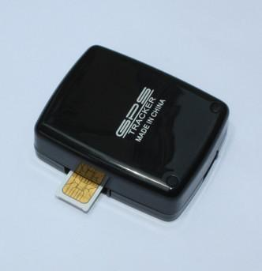

5. Change Password

Command: W******,001,######
Description: Change user‟s password.
Note:

1. ****** is user‟s password and the default password is 000000. The tracker will only accept commands
from a user with the correct password. Commands with wrong password will be ignored.

2. ###### is the new password. Password should be 6 digits.
Example:

W000000,001,123456

W123456,001,999999

6. Time Zone

Command: W******,032,T
Description: Correct time into your local time
Note:
1. Default time of the tracker is GMT
2. This correction is applied to location reports by SMS and SMS alarms.
T=0, to turn off this function.
T=[-32768,32767] to set time difference in minute to GMT.
For those ahead of GMT, just input the time difference in minute directly. For example, GMT+8,
W000000,032,480
„-„is required for those behind GMT. For example, W000000,032,-120.
Example:

W000000,032,480

W000000,032,-120

7. Track

7.1 Track by position

- Track on Demand - Reply with longitude, latitude
Command: W******,000
Description: Sending the command to the current position locator locator to query, reply to the message
format is as follows:
Latitude = 22.604273N Longitude = 114.055046E Speed = 0.00 14/07/31 12:20 F:3.8V,04,01CC 0000 25F0 10D9
Example: W000000,000

- Track on Demand - Reply with a link to Google Map
Command: W******,100
Description: Send this command to the tracker and then you receive an SMS with an http link. Click on the
link then the location can be shown directly on Google Map on your mobile phone. For example:
http://maps.google.com/maps?f=q&hl=en&q=22.540103,114.082329&ie=UTF8&z=16&iwloc=addr&om=1
Notes: Only smart phones and PDA support this function.
Example:

W000000,100

7.2 Track by Calling

Make a missed call to the tracker,after hanging up the phone is switched on, locator will return reply to
the message format is as follows:

Latitude = 22.604273E Longitude = 114.055046N Speed = 0.00 14/07/31 12:20 F:3.8V,04,01CC 0000 25F0 10D9

Latitude : 22.604452E Longitude: 114.054482N speed: 0 positioning time date 14/07/31 12:20 battery voltage F:3.8v. GPS signal satellite number; 04 base station positioning code MCC:01CC MNC:0000 LAC:25F0 Cell ID:0F34
7.3 Track by Preset Interval

Command: W******,002,XXX
Description: Set an interval for the tracker to continuously return its location by SMS
Note:
1. XXX is the interval in minute.
2. If XXX=000 to turn off tracking by time
Example:

W000000,002,030

The tracker will send location data back to your mobile phone every 30 minutes.

7.4 Google Earth and Google Map

Download Google Earth from http://earth.google.com/ .
Start Google Earth (For more information about Google Earth please refer to http://earth.google.com/ ) or
go to http://maps.google.com in your Internet Explorer
Input the latitude and longitude that you receive from the tracker by SMS and click the search button.
Google Earth or Google Maps will display the location for you.
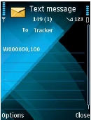

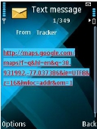

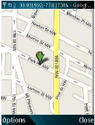

Example:

When you receive: Latitude = 22 32 40.05N Longitude = 114 04 57.74E
Type as the following picture shows:
(Note: you should input the latitude and longitude as: 22 32 40.05N 114 04 57.74E)

And then you can find the location of your tracker:

Or you can use local map software on PDA or car navigation device to input the coordinates.

7.5 Track by GPRS between Server and Tracker

7.5.1 Set Tracker’s GPRS ID
Command: W******,010,ID
Description: Set a digital GPRS ID for the tracker.
Note: GPRS ID must not over 14 digits.
Example:

W000000,010,00001

7.5.2 Set APN
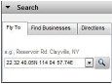

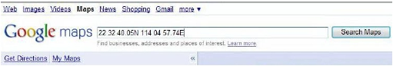

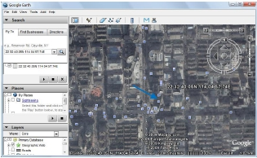

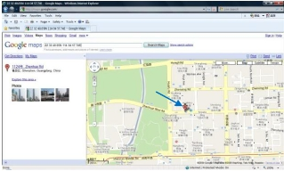

Command: W******,011,APN,Username,Password
Description: Set APN details for the tracker
Note:
1. APN username and password are optional. If no APN username and password are required, just input APN
only;
2. APN defaulted as „CMNET‟;
3. APN + username + password should not over 39 characters.
Example:
W000000,011,CMNET,user,6688
W000000,011,CMNET

7.5.3 Set IP and Port
Command: W******,012,IP,Port
Description: Set IP and Port for tracker for GPRS communication.
Note:

1. IP is your server‟s IP or the domain name.
2. Port: [1,65534]
Example:

W000000,012,183.61.0.83,7788

W000000,012,www.track.com,7788 SMS query machine set TCP, IP port, APN, device ID

SMS commands to w*******, 701
Example:

W000000，701

TCP,183.61.0.83,8887,cmnet,card,card,139666666661

7.5.4 Set DNS Server IP (optional)
Command: W******,009,DNS Server IP
Description: In case the domain name you set by the last command (W******,012,IP, Port) doesn‟t work,
which means your server IP is not properly set. You can first use this command to set DNS Server IP (please
check with your DNS server provider for the DNS Server IP) and then redo the command W******,012,IP,
Port.
Example: W000000,009,220.23.4.90

7.5.5 Enable GPRS Tracking
Command: W******,013,X
Description: Enable GPRS tracking function.
Note:
X=0, to turn off GPRS tracking (default);
X=1, to enable GPRS tracking via TCP
X=2, to enable GPRS tracking via UDP
Example: W000000,013,1

7.5.6 Set GPRS Time tracking
SMS commands: W******, 014, XXXXX
Description: set GPRS to upload the positioning information packet interval.
Explain.
XXXXX is the 5 digit, to 1 second as unit.
XXXXX=00000, closed
XXXXX=00001~65535, upload time interval (in seconds as a unit)
For example: W00000001400060
Position every 60 seconds to upload a GPRS data.

7.5.7 Set GPRS Interval
Command: W******,014,XXXXX
Description: Set time interval for sending GPRS packets.
Note:
XXXXX should be in five digits and in unit of 10 seconds.
XXXXX=00000, to turn off this function;
XXXXX=00001~65535, time interval for sending GPRS packet and in unit of 10 seconds.
In this example, the tracker will send every 600 seconds (10 minutes).

Example: W000000,014,00060
The tracker will send every 600 seconds (10 minutes).

For more information regarding GPRS tracking please refer to <GPRS Communication Protocol>

- LED lights switch SMS commands

W******,055,x

X=1,Open led

X=0,Close LED
Example

W000000,055,1

8.1 Set SOS authorized number SMS commands
W ******, 103, T
T ; authorization number, maximum 16.
example
w000000,103,88888888

10. Speeding Alarm

SMS commands: W******, 005, XX
Description: set the overspeed alarm. When the mobile speed positioner is higher than the preset value will send alarm information to the SOS authorization number.
Description: XX for the preset speed value, two digit.
=00, close the overspeed alarm
=[01, 20] set the speed (unit: 10 km / h)
For example: W000000005,08
When the positioning speed over 80 km / h, to send the alarm information.

11. Movement/Geo-fence

11.1 Movement Alarm

Command: W******,006,X
Description: When the tracker moves out of a preset circle scope, it will send an SMS alarm to the
authorized phone number for SOS.

Note:
1. X is the preset radii to the tracker‟s original place
=0, to turn off this function
2. Radii: [1, 4294967295] meter(s), suggest to be set above 100 meters;
3. GPRS command is 0x12
Example: W000000,006,1

When tracker moves out of this circle scope, it will send out an SMS alarm.

11.2 Geo-fence Alarm

Command: W******,302,X
Description: Turns on Geo-fencing alarm. When the tracker moves in/out the preset scope, it will send an
SMS alarm to the authorized phone number for SOS.
Note:
1. X is the parameters which includes: latitude, longitude, radii, in, out;
2. Latitude and longitudes should be in ASCII format as follows:
Latitude is ddd.dddddd, „0‟ is needed to be stuffed if no value available. „-‟ should be added for south.

=1, 30m | =2, 50m | =3, 100m | =4, 200m
=5, 300m | =6, 500m | =7, 1000m | =8, 2000m

Longitude is dd.dddddd, „0‟ is needed to be stuffed if no value available. „-‟ should be added for west.
3. Radii: [1, 4294967295] meter(s), suggest to be set above 100 meters, if set above 8, it is corresponding
radii;
4. If In and Out are 0, corresponding function is invalid, if are 1, valid;
5. Reply as Geo-Fence Alarm;

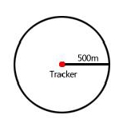

6. GPRS exiting command is 0x12, entering command is 0x13;
7. Send W******, 302 to turn off Geo-fence function;
Example:

W000000,302,22.000000,-114.123456,3000,1,1

Remarks:
1. Only one alarm can be set in either In or Out;
2. Only one alarm can be set in either Movement Alarm or Geo-fence Alarm.

12. Track by Distance

Command: W******,303,X
Description: Send this command to set distance interval
Note:
1. X= [1, 4294967295], suggest to be set above 300 meters
2. X=0, turn off
Example: W000000,303,1000

12.1 remove blind data storage
SMS commands: W******, 703
Description: if the cached data is not important, as long as uploading new data,use this command.
Description: clear the blind area of the stored data will not be returned
For example: W000000703
Reply: clear exflash data OK

13. Set Sensitivity of Tremble Sensor

Command: W******,035,XX
Description: Send this command to set sensitivity of tremble sensor
Note:
1. XX=[1,255], it will more sensitive if XX is more smaller
2. Default value is 30
Example: W000000,035,30

13. Listen-in (Voice Monitoring)

Command: W******,030,T
Description: Authorize a phone number to make a silence call to the tracker, the track answers the call
automatically and allows the caller to listen to what happens around the tracker. There is no voice indication
that the call is in progress
Note:
1. T is the telephone number for wiretapping and max. 16 digits
2. Calls from unauthorized number are treated as normal incoming calls and indicated by beeps.
Example:

W000000,030,88888888

14. Heartbeat

Command: W******,015,data
Description: Set an interval for heartbeat.
Note:
data is the interval in unit of minute
data=0, to turn off this function;
data=1~65535, set interval for heartbeat.
Example:

W000000,015,10

In this example, the tracker will send heartbeat every 10 minutes.

15. Power Down

Command: W******,026,XX
Description: Make the tracker into power down mode when it is inactive or immobile for a period of time.
In Power Down states, GPS stops working and GSM enters sleep and stop sending out message until it is
activated by message, incoming calls or movement or triggered by three buttons.
Note:
XX=00, to turn off this function.
XX=01~99, to turn on Power Down after a specified period of being inactive (or stationary). It is in unit of
minute.
Example: W000000,026,10
The tracker will enter power down mode after it is inactive (or stationary) for 10 minutes.

16. Get IMEI

Commands: W******, 601
Description: read device IMEI number
Note: IMEI is usually 15 digit
For example: W000000601

Reply: 011691002271305

W000000600 SMS commands to get version information

17. Initialization

Command: W******,990,099###
Description: This is to make all settings (except for the password) back to factory default.

### is the ending character and is required in the text message.
Example: W000000,990,099###

18. Password Initialization

Command: W888888,999,666
Description: This is to make the password back to factory default in case you forget your password..
If you had set authorized telephone number, when password preset successfully, the telephone will get
W888888,999,666
Example: W888888,999,666

For more details regarding SMS commands, please go to Annex 1 Command List.

19. Parameter Editor

The tracker can be configured by computer using the Parameter Editor.

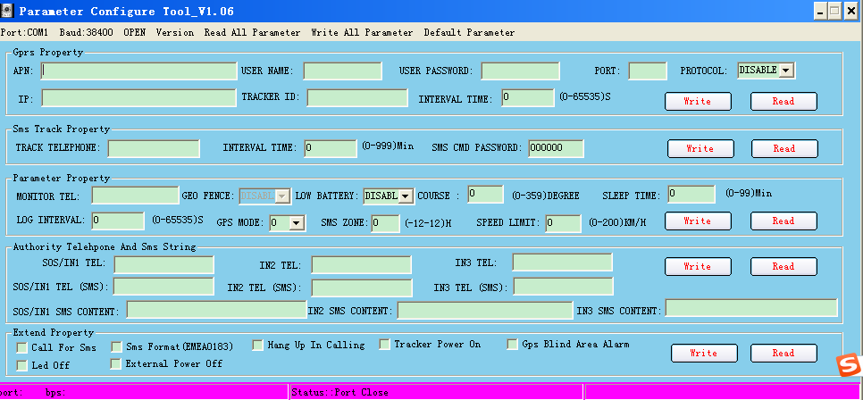
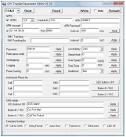

Annex 2. Troubleshooting

Problem: Unit will not turn on
Possible Cause: | Resolution:
Battery needs charging | Recharge battery for 3 hours
Problem: Unit will not reply with SMS
Possible Cause: | Resolution:
Green LED is flashing (1 second on and 2  seconds off) | Make HS-500P connected to GSM network.
GSM Network is slow | Some GSM networks slow down during peak time or when they have  equipment problems.
Unit is sleeping or in power down mode | Cancel sleeping mode or power down
Wrong password in your SMS or wrong SMS  format | Write correct password or SMS format
The SIM in HS-500P has run out of credit | Replace or top up the SIM card
Problem: Green LED is Flashing (1 second on and 2 seconds off)
Possible Cause: | Resolution:

No GSM signal | Check with a mobile phone to see if there is a signal in the area or try to call  the unit to see if you hear a ring tone.
No SIM card | Insert a working SIM card. Check in phone that the SIM can send SMS  message.
SIM card has expired | Check in phone that the SIM can send SMS message. Replace SIM card if  needed.
SIM has PIN code set | Remove PIN code by inserting SIM in you phone and deleting the code.
SIM is warped or damaged | Inspect SIM, clean the contacts. If re-inserting does not help try another to  see if it will work.
Roaming not enabled | If you are in a different country your SIM account must have roaming  enabled.
Battery is low | Recharge the unit and the GSM will start working.
Problem: Blue LED is Flashing (1 second on and 2 seconds off) or the SMS received starts with ‘Last…’
Possible Cause: | Resolution:
Unit does not have clear view of the sky | Move the unit to a location where the sky is visible. Tall buildings, trees,  heavy rain, can cause problems with the GPS reception.
Bad GPS reception | Place the front side of HS-500P towards sky
Battery is low | Recharge the unit and the GPS will start working.
Problem: Unit Fails to Connect to Server via GPRS
Possible Cause: | Resolution:
SIM card in HS-500P does not support GPRS  function | Enable SIM card GPRS function.
GPRS function of HS-500P is turned off | Turn on GPRS function of HS-500P.
Incorrect IP address or PORT | Get the right IP address and PORT and reset to HS-500P.
GSM signal is weak | Move the unit to a location with good GSM reception.

